**Profile**

Presently the page is displaying as below

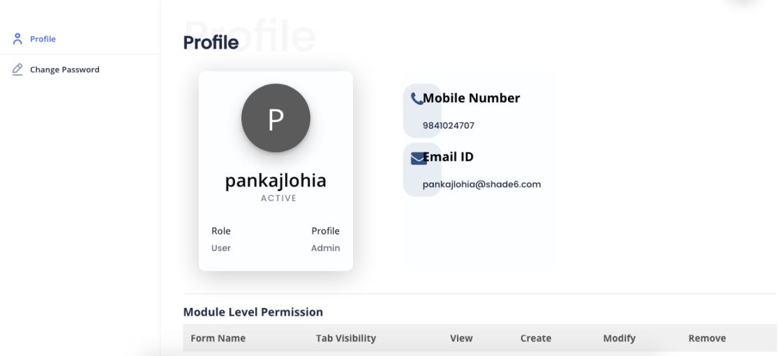

It should be modified to

Profile

Profile

Change Password

**PL**

**Mobile Number**

**9841021414**

PANKAJ LOHIA

**Email**

**[nsramakrishan@gmail.com](mailto:nsramakrishan@gmail.com)**

**Role. Profile**

**Admin. Admin**

Permissions

**Form Name. View. Create. Modify. Remove**

Role

Profile

User

Organisation

Organisation Logo

Lookup

Notification Setting

Template

Auto generation

Language

Logfile

Territory

Lead Quality

Scoring Rules

Deal Probability

Social Media

**Dash Board**



Users : Total Users count from Plan

Users add in this month : No of users created in current month

Users not Invited Yet : Total users Count as per plan – Total User Created so far.

Users not joined yet : No of users created but not logged in sofar.

Remove pending user

Modules : total count from plan

Next Renewal date : Subscription Date plus one year

Signed in Users : no of users signed in count for the day

Sign in Dettails : Successful Sign : Total users signed in with out failed (For the day)

Failed Signin : Total users failed to sign in . Like Login Failed due to credentials.(For the day)

Active users : List of Users signed in at that time. If users have loged in and loged out will not be counted.

I

In left side menu

* Dash Board
* Account Setting

On click Account Setting it will redirect to another Page . My Account Tab is default.

My Account

Additional License Request

Add Storage Request

Upgrade Plan Request

Cancel Plan Request

Create a Ticket

Plan Name

Plan Id

Package Name

Package Id

Subscription Date

Expiry Date

Modules

Addons

Storage Available

Storage Allocated

No of Users

If the Role is “Admin” and Profile is “Admin” he/she will be treated as a “Super Admin” for the Client. **The Super Administrator will have User Id as “Administrator” and only one Administrator will be given by Foyer when the client subscribed.**

The super administrator will be having the access for Account Settings but he will not have access to user .

**Additional License Request**

Here the Super Admin can request Foyer to add some more users in the existing plan. The following form to be used to send the request.

On Click of Additional License Request it will display

Create a Request

Search

Date. Request No. Plan name. Total License Add/ Reduce license. License after Effective Dt Status Action

01/02/2020. REQ001. Basic Plan. 10. 3. 13. 15/02/2020. Request Sent Edit/Del

**Add or Cancel License Request**

Request No

Request Date

Plan Name

Customer Name

Add / Cancel

No of Users

No of License

Effective Date

Send Request

Save

Request No : It is autogenerated Code : The format shall have prefix as “LREQ” and the no is increamental “00001”, “00002” (LREQ00001)

Request Date : System Date

Customer Name : By default – Company Name (Display)

Plan Name : By Default (Display)

No of Users : Existing no of Users (Display)

Add/Cancel : Choose one (To add License or Reduce License)

No of License : To be entered (Mandatory)

Effective Date : Mandatory (It shall be more than Request Date)

On Click Save The record will be saved and Send Request button will appear but it will not sent unless clicked by Super administrator. Once Send Request will be clicked A popup will appear for confirmation.

If the request is for additional License the popup will be like

Request No. : LREQ0001

Request for : Additional License

No of Licenses 3

Effective Date. 15/02/2020

By sending this request you will get an invoice for the additional cost. Once you pay the amount the additional licenses will be activated. The process may take some time. You shall not expect the no of additional users get activated as soon as you send this request. For any queries you may contact us by email to sales@foyertech.com

**Cancel**

**Send Request**

If the request is for Reducing License the popup will be like

Request No. : LREQ0001

Request for : Cancel License

No of Licenses 3

Effective Date. 15/02/2020

By sending this request you are confirming the reduction of 3 licenses from the existing no of licenses. Once it is deactivated, you may not activate again. To get more license you may have to send a request for additional licenses. The process may take some time. You shall not expect the no of users deactivated as soon as you send this request. For any queries you may contact us by email to sales@foyertech.com

**Send Request**

**Cancel**

The status in list view will be updated once the request button clicked. If the request Sent The Status will be “Request Sent” otherwise “Draft “ but if the request is approved by Foyer and the request is completed(means the user are activated) it shall be “Completed”.

Once the Super Adminstartor sends the request to Foyer Superadmin , a mail shall be sent along with following content

Hello,

With this mail we are confirming our request for an additional license of <<Nos>> . Please do the needful.

Request No : xxxxxxxxxxxxxxx.

Request Date: xx/xx/xxxx

Request for : Additional License

Quantity : xxxx Licenses

Please click below link to take action

Url :xxxxxxxxxx.xxx/xxxxxx/xxxxxx/xxxxxx

URL :

Company Name

**Additional Storage**

Here the Super Admin can request Foyer to add some more Storage in the existing plan. The following form to be used to send the request.

On click additional storage it will display the list view.

Create a Request

Search

Date. Request No. Plan name. Total Storage Add Storage. Storage after Effective Dt Status Action

01/02/2020. REQ001. Basic Plan. 1 GB 1GB 2GB 15/02/2020. Request Sent Edit/Del

**Additional Storage**

Domain Name

Customer Name

Request No

Request Date

Additional Storage

Allocated Storage

Total Storage <<Total Storage After>>

Send Request

Save

Request No : It is autogenerated Code : The format shall have prefix as “SREQ” and the no is increamental “00001”, “00002” (SREQ00001)

Request Date : System Date

Customer Name : By default – Company Name (Display)

URL Name : By Default (Display)

Allocated Storage : Existing Storage (Display)

Additional Storage : To be entered (Mandatory)

On Click Save The record will be saved and Send Request button will appear but it will not sent unless clicked by Super administrator. Once Send Request will be clicked A popup will appear for confirmation.

If the request is for additional License the popup will be like

Request No. : SREQ0001

Request for : Additional Storage

Additional Storage 1 GB

By sending this request you will get an invoice for the additional cost. Once you pay the amount the additional storage will be activated. The process may take some time. You shall not expect the no of additional Storage get activated as soon as you send this request. For any queries you may contact us by email to sales@foyertech.com

**Cancel**

**Send Request**

The status in list view will be updated once the request button clicked. If the request Sent The Status will be “Request Sent” otherwise “Draft “ but if the request is approved by Foyer and the request is completed(means the user are activated) it shall be “Completed”.

Once the Super Adminstartor sends the request to Foyer Superadmin , a mail shall be sent along with following content

Hello,

With this mail we are confirming our request for an additional storage of <<storage>> . Please do the needful.

Request No : xxxxxxxxxxxxxxx.

Request Date: xx/xx/xxxx

Request for : Additional storage

Quantity : xxxx GB

Please click below link to take action

Url :xxxxxxxxxx.xxx/xxxxxx/xxxxxx/xxxxxx

URL :

Company Name

On Click Create Ticket

The Following list view will display

**Add a Ticket**

Ticket No. Date. & Time. Ticket Subject. Ticket Status. Date of Completion. Action

TIKT00002. 2/12/2020 10:30 AM. Lead Scoring not working. Open. Edit/Del

There shall be a hyperlink on Ticket No. On click the Ticket No it will display a form as below

Subject

Date

Ticket No

Details

**CrmFarm Team Response**

Ticket Status

On click Create a Ticket the following form shall display and capture the ticket information

Ticket Severity

Ticket Subject

Date & Time

Ticket No

**Cancel**

**Submit**

Details

**Role** : This basically to create the reporting structure of employees in an organization. Hence the whole organization shall be viewed like a tree.

For Example

In a Company CEO is the root

Vice presidents are reporting to CEO

General managers are reporting to Vice President

Managers are reporting to General Managers

View Role shall be look like

* CEO
  + Vice President1
  + Vice President2
    - General Manager1
      * Manager
    - General Manger2
      * Manager
      * Manager

On roll over Edit / Del button shall be displayed like

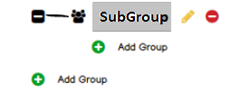

On clicking the edit button the role to be edited and saved. In case of delete if the below hirechy is there it can not be deleted or if the role is linked to any table it can not be deleted.

**Create Role**

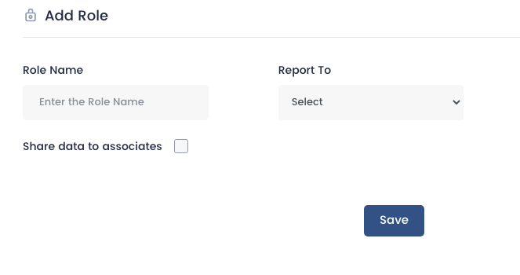

**Role Name :** Mandatory and minimum 3 characters . It shall not accept any special character or numerics. It can not be duplicate.

**Report to :** shall be captured from the dropdown . Roles captured from role table. Search option shall be available.

There shall be a Cancel button along with the Save button.

Share data to associate : It means the users mentioned associates shall be access to view , edit, delete the records created by the role.

**Profile** : Profile is nothing but the access and rights given to various users. Here there will be two profiles comes by default however Admin can create more profile depends upon the nature of operation

To create profile the system should have a form master where all forms shall be available. The list of forms are entered back end and listed in profile form.

**List Profile**

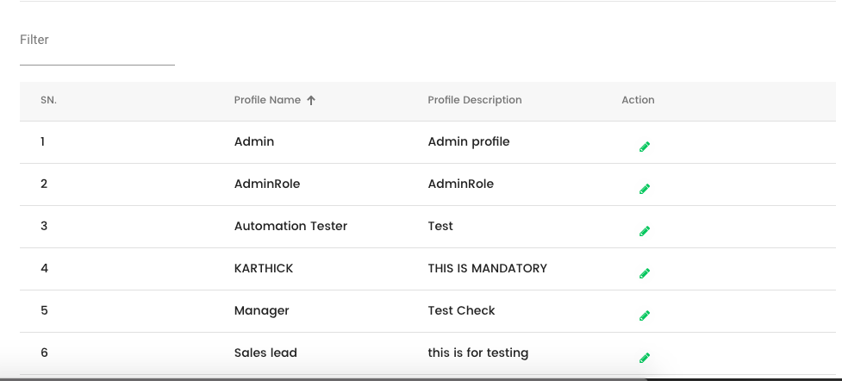

Instead of Filter it should be used as Search and it should be right side instead of Left side.

Delete Profie is missing.

In case of delete it shall check the record referenced in any table . If referenced it should not be deleted and throw an error Message like “This Profie is linked with some other records . Can not be deleted”

**Form List for Admin**

|  |  |  |  |  |
| --- | --- | --- | --- | --- |
| Form Name | Visible Tab | Create | Modify | Remove |
| Role |  |  |  |  |
| Profile |  |  |  |  |
| User |  |  |  |  |
| Organisation |  |  |  |  |
| Organisation Logo |  |  |  |  |
| Lookup |  |  |  |  |
| Notification |  |  |  |  |
| Template |  |  |  |  |
| Autogeneration No setup |  |  |  |  |
| Language |  |  |  |  |
| View Logfile |  |  |  |  |
| Teritorry |  |  |  |  |
| Lead Quality |  |  |  |  |
| Scoring |  |  |  |  |
| Deal Probability |  |  |  |  |
| Social Media |  |  |  |  |

Depends on the access rights the forms can be accessed.

Same way the Access to given to users

Hence by default two profiles shall be there. The admin can clone the profiles to create more profiles by editing the access rights.

**Users**

In View User

User Id User Name. Created by. Created Date. Action

[Cramakrishnan@labindia.com](mailto:Cramakrishnan@labindia.com) C Ramakrishnan. administartor@labindia,com. 02/02/2019. Edit/Del

On Click of User Id User profile shall be displayed for Admin only. Admin can activate and deactivate the account.

C Ramakrishnan

*Joined Date : 01/06/2018*

**CR**

Active

Status

Privileges

|  |  |  |  |  |
| --- | --- | --- | --- | --- |
| Form Name | Visible Tab | Create | Modify | Remove |
| Role |  |  |  |  |
| Profile |  |  |  |  |
| User |  |  |  |  |
| Organisation |  |  |  |  |
| Organisation Logo |  |  |  |  |
| Lookup |  |  |  |  |

Admin can edit the profiles of all employees including other Admins. However User Admins (Which are created by Admin) can not edit other Admins profile. But they can edit the users profiles.

**Create an User**

The form is presently

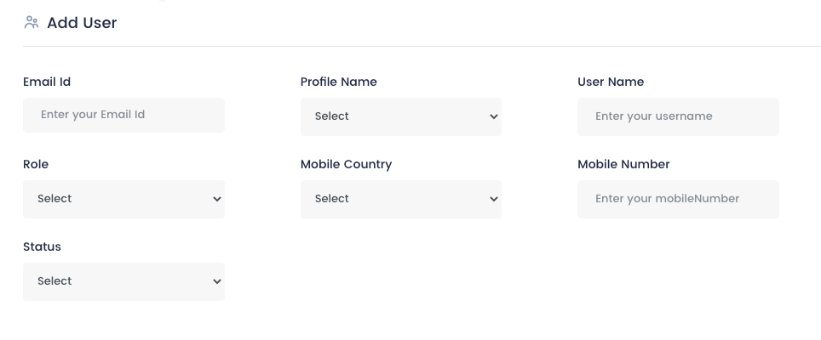

**Next >>**

On clicked Next button the privileges will be displayed according to the profile selected. However Admin can add or remove privileges on user to user basis.

**Privileges**

|  |  |  |  |  |
| --- | --- | --- | --- | --- |
| Form Name | Visible Tab | Create | Modify | Remove |
| Role |  |  |  |  |
| Profile |  |  |  |  |
| User |  |  |  |  |
| Organisation |  |  |  |  |
| Organisation Logo |  |  |  |  |
| Lookup |  |  |  |  |
| Notification |  |  |  |  |
| Template |  |  |  |  |
| Autogeneration No setup |  |  |  |  |

Cancel

Save

Once clicked Save button the record will saved along with privileges given to the user. On click Cancel button the form will be reset .

**Organisation**

Organisation will be created by Foyertech Superadmin portal by Superadmin

The Super Admin must enter

Organisation Name

Address

Contact Person (Billing)

Contact Email Id (Billing)

Contact Phone (Billing)

Currency

Website

Company Name , Contact Person Name, Contact Email Id, Contact Phone, Currency can not be Edited. All other information can be edited by the Administrator.

Note : Red colored texts are new fields to be created in Organisation Table

**Organisation Logo**

Adminisytrator can upload Logo . When upload the size should not exceed 500kb. It can be resized.

**Look up**

View Lookup

Lookup Id. Lookup Name. Details. No of Values. Actions

LKP00001 Account Type. This is used to identify Accounts. 10. Edit/Del

**Create Lookup**

It shall have fields

Lookup Name Lookup Name

Lookup Description

Status

On click Save it will save in header file with a Lookup Id (Which is autogenerated) LKP00001.

**Notification**

In Notification an Admin can create Notification, Create a Template for Notification and set up the notification.

**Create Notification**

Notification Name Notification Category(Contact, Lead, Deal, Accounts)

Notification Details

Cancel

Save

**Create Template**

Template Name

Notification Content

Save

Cancel

**Add Notification**

**Notification setup**

|  |  |  |  |  |  |
| --- | --- | --- | --- | --- | --- |
| Notification | Category | Frequency | Days/Month | Template | Action |
| Un Touched Leads | Lead | 15 | Days | Temp1 | Edit/del |
| Meeting follow up | Contact | 1 | Month | Meeting Temp | Edit/del |
| Visit Follow up | Lead | 1 | Month | Visit Temp | Edit/del |
| Deal Meeting | Deal | 15 | Days | Temp1 | Edit/del |

**Other Setup**

**Autogeneration No**

In this form all forms document code property is set. It means when the record is saved after entry, the document is whether manual or autogenerate is required. If the no is autogenerate then how the no should be generated and if manual the code shall be entered which will be always mandatory.

To create this functionality first all forms available shall be entered from backend to a table in db. And then in auto generation form all tables names shall be displayed along with the form id and Admin has to set the property of the auto generation codes.

1. **Table Name : form_master;**

|  |  |  |  |  |  |
| --- | --- | --- | --- | --- | --- |
| Field | Type | Null | Key | Default | Extra |
| form_key | int(5) | NO | PRI |  | auto_increment |
| form_id | varchar(8) |  |  |  |  |
| frm_modulename | varchar(30) |  |  |  |  |
| frm_name | varchar(100) |  |  |  |  |
| frm_description | varchar(255) |  |  |  |  |
| frm_delete_status | tinyint(1) |  |  | 0 |  |
| frmCreatedBy | varchar(10) |  |  |  |  |
| frmCreatedDate | Date |  |  |  |  |
| frmUpdatedBy | Varchar(10) |  |  |  |  |
| frmupdatedDt | Date |  |  |  |  |

**MODULE NAME: FormTransactionNoSetup**

**2. Table Name : TransactionNo_master;**

|  |  |  |  |  |  |
| --- | --- | --- | --- | --- | --- |
| Field | Type | Null | Key | Default | Extra |
| FormCode | varchar(10) | NO | Pri |  |  |
| Autogen_type | TinyInt(1) |  |  | Manual / Auto |  |
| Autogen_prefix | varchar(3) |  |  |  |  |
| Autogen_suffix | varchar(3) |  |  |  |  |
| Autogen_startno | varchar(10) | NO |  |  |  |
| Autogen_endno | varchar(10) | NO |  |  |  |
| Approvalrequired | tinyint(1) |  |  | Yes / No |  |
| CreatedBy | Varchar(10) |  |  |  |  |
| CreatedDate | Date |  |  |  |  |
| UpdatedBy | Varchar(10) |  |  |  |  |
| UpdatedBy | Date |  |  |  |  |

**Form Master**

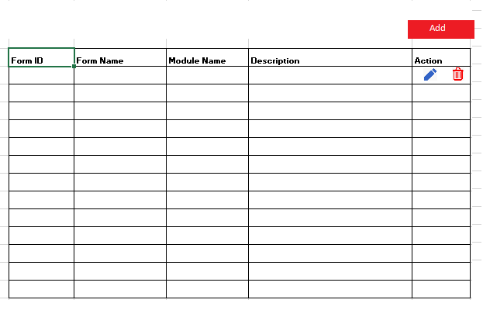

**Autogeneration setup**

|  |  |  |  |  |  |  |
| --- | --- | --- | --- | --- | --- | --- |
| Form Name | Form Id | No. Gen Type | Prefix | Sufix | Start No | End No |
| Role | FRM0003 | Autogenerated | ROL |  | 00001 | 99999 |
| Profile | FRM0010 | Manual |  |  |  |  |
| User | FRM0056 | Autogenerated | USR |  | 00001 | 99999 |
| Organisation | FRM0022 | Autogenerated | ORG |  | 00001 | 99999 |
| Organisation Logo | FRM0021 | Autogenerated | OLG |  | 00001 | 99999 |
| Lookup | FRM0035 | Autogenerated | LOK |  | 00001 | 99999 |
| Notification | FRM0065 | Autogenerated | NOT |  | 00001 | 99999 |
| Template | FRM0029 | Autogenerated | TMP |  | 00001 | 99999 |
|  |  |  |  |  |  |  |
|  |  |  |  |  |  |  |

Save

It will always to be Edit mode and can be saved once user clicks Save button

**Language**

Language can be selected from English, German, Arabic, and Spanish. Presently it is showing only English. Once the language is set the application will convert to language selected.

**View Logfile**

It should be shown 10 records per page. One button shall be available to archive the logfile so that all records will be added in archive table. So that it should not be any problem for performance issue.

**Teritorry Mangement**

It should be as per the spec provided.

**Lead Quality**

Change the name to Lead Stage from Lead Quality

**Lead Attributes**

Before setting the Scoring one must consider the on which basis the scoring will be calculated. Hence it is important to have the attributes first.

**View Attributes**

**Add a Attribute**

|  |  |  |  |  |  |
| --- | --- | --- | --- | --- | --- |
| Attribute Name | Table Name | Field Name | Field Type | Lookup Name | Action |
| Industry | Lead_Master | Lead_IndustryType | Combo box | IndustryType | Edit/Del |
| Annual Revenue | Laed_Master | Lead_Annual_Rev | Numeric |  | Edit/Del |
| Not Available | Lead_Phone | LeadPhone_Avlbl | Logical |  | Edit/Del |
|  |  |  |  |  |  |
|  |  |  |  |  |  |

**Scoring Rules**

**Phone Activity**

**Email activity**

**Deal**

**Lead Property**

|  |  |  |  |  |
| --- | --- | --- | --- | --- |
| Attribute | Logical Parameter | Value | Add / Sub | Score |
| Industry | = Equals To | IT Industry | Add | 10 |
| Annual Revenue | > Greater Than | 500000000 | Add | 10 |
| Not Available | = Equals To | Yes | Sub | 5 |
|  |  |  |  |  |
|  |  |  |  |  |

**Save**

Here in Value column, If the Choice is Yes / No in application the user can choose only Yes/No

If the field is a dropdown in application, it will take the value from the drop down

If the field is a numeric amount in application user have to enter only numeric value only.

Logical Parameter

- Is, Is Not

- Yes , No

- > Greater Than

- = Equal To

- < Less Than

**Value**

* Yes / No
* Or Numeric Value (In case of amount like turnover)

Add / Sub

Incase Add the score will added and incase of Sub the score will be subtracted.

Score will be entered